Data Protection Using Encryption
Task 1: Create an AWS KMS key
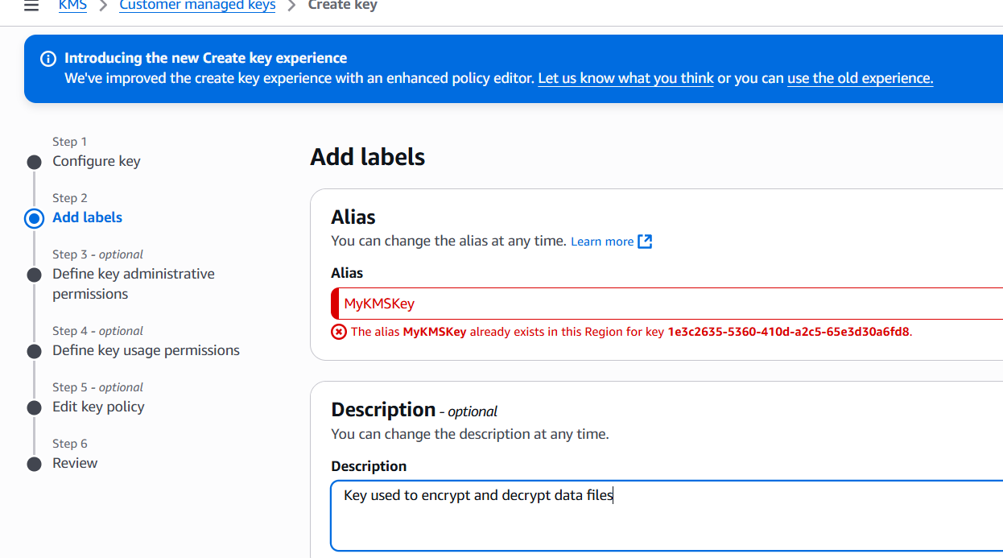

Task 1: Create an AWS KMS key
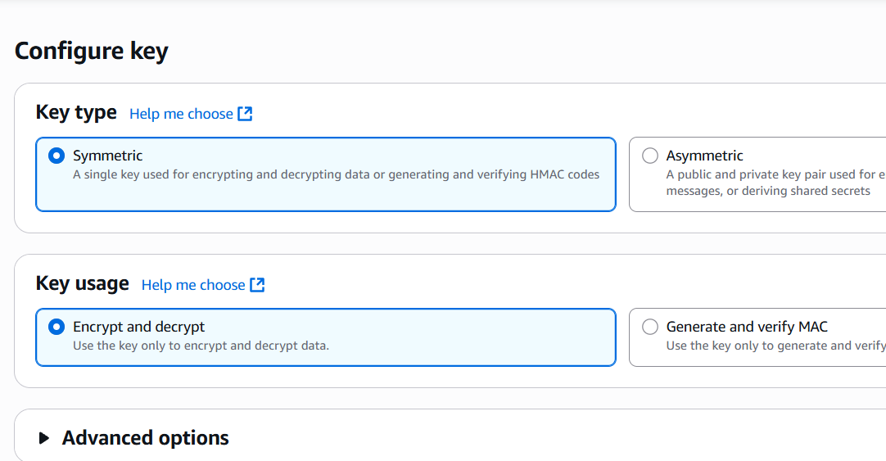
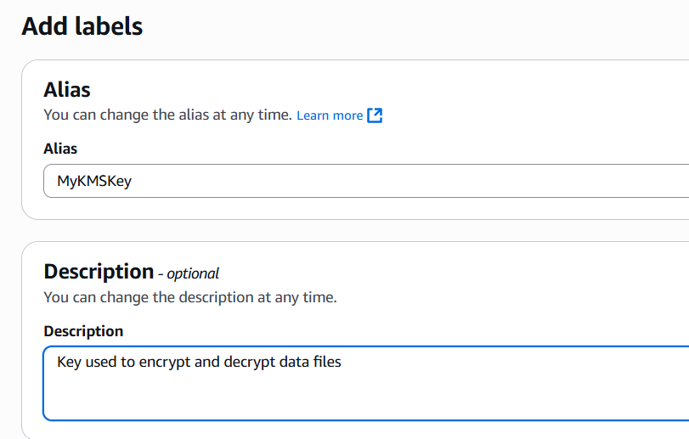
Task 2: Configure the File Server instance
To open the AWS credentials file, run the following command:

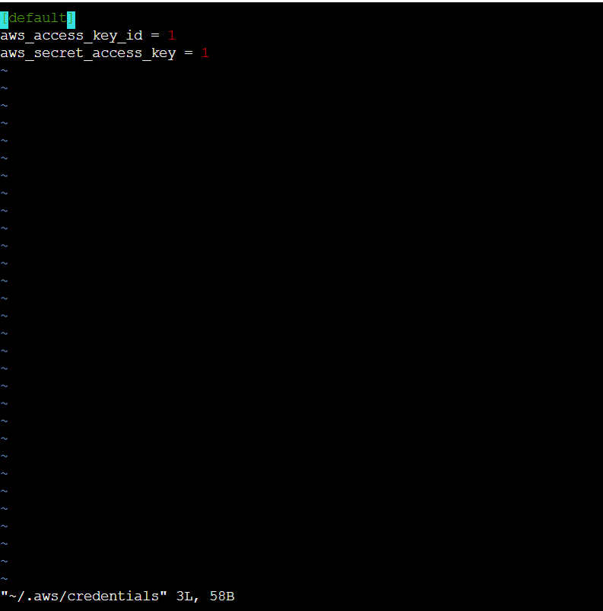

- On the Define key administrative permissions page, in the Key administrators section, search for and select the check box for voclabs and then choose Next.

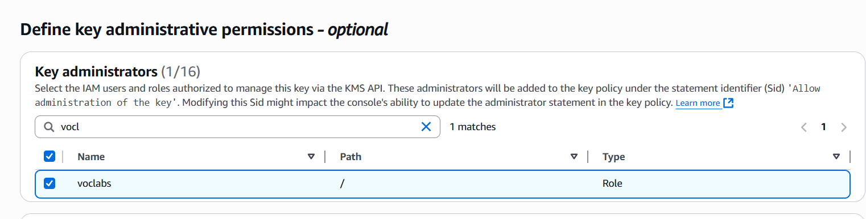
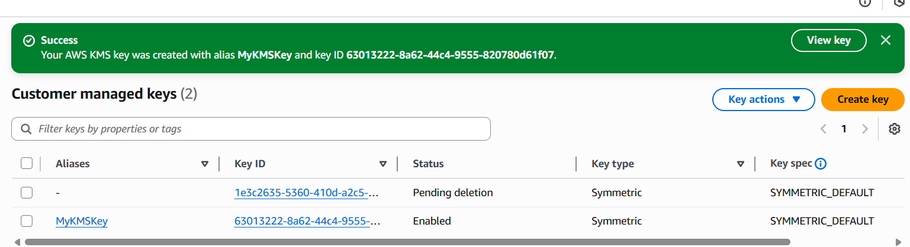
Task 2: Configure the File Server instance
- To open the AWS credentials file, run the following command:
vi ~/.aws/credentials

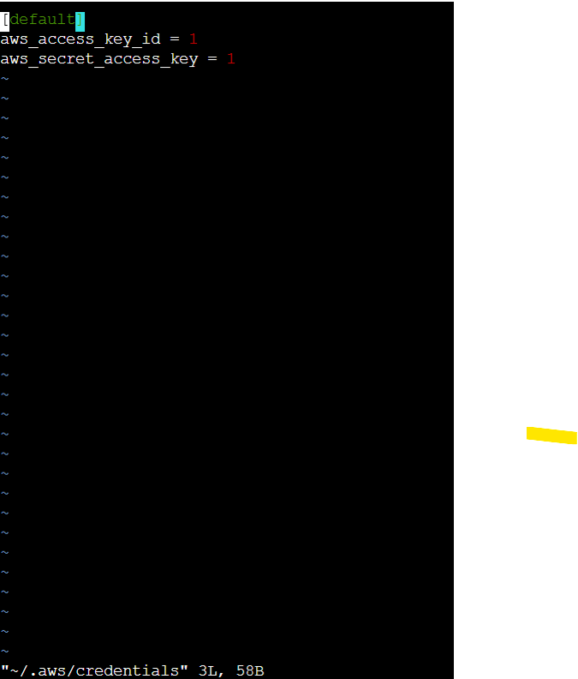

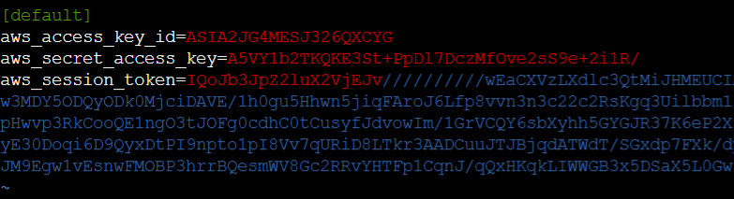
To view the updated contents of the file, run the following command:
cat ~/.aws/credentials
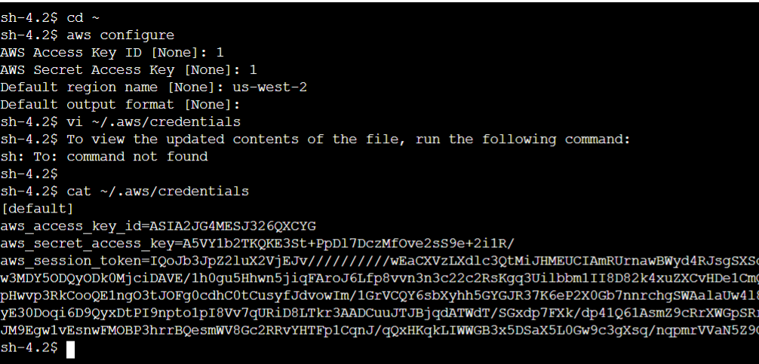
- To install the AWS Encryption CLI and set your path, run the following commands:
pip3 install aws-encryption-sdk-cli
export PATH=$PATH:/home/ssm-user/.local/bin
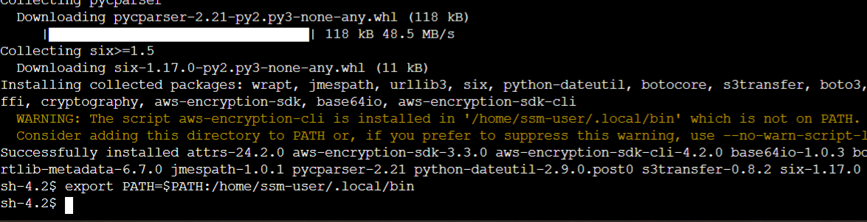
Task 3: Encrypt and decrypt data
We first create the demo file:
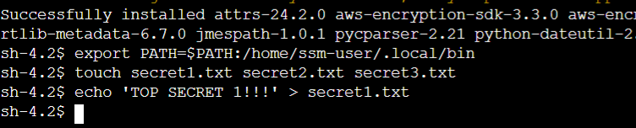
Next we encrypt the secret1.txt file
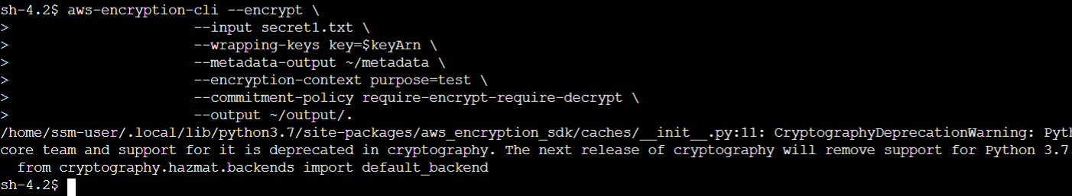
The file has been ecrypted:
